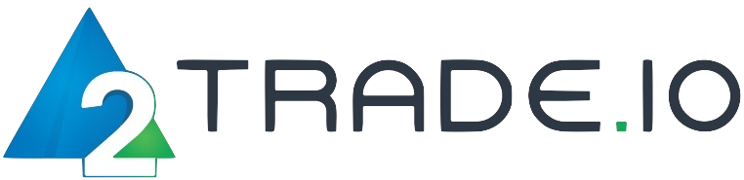

* Operation of financial

instruments exchange

* System development

Aragona Capital.Ltd

Gladstonos M. Kyprianou House 3rd

and 4th floor Limassol Cyprus

Company

EA

Pro Traders

or

Personal Traders



Social Account



Social Account



Social Account

WHAT IS SOCIAL ACCOUNT?

Social Account is a system that many users can share (copy). One social account can incorporate one or more automated trading software (= EA) and trading by specialized traders. Or you can incorporate both. This gives general investors access to a variety of trading techniques.

SOCIAL ACCOUNT

ONLY MT5

* Up to now, VPS has been used to connect between systems, but they are not needed at all
* There is no time for the master unit to send trade data to the sub unit
* There is no system error due to signal between the master and sub

BENEFIT 2

BENEFIT 1

・Investors do not have to buy a system from an EA sales company and incorporate the EA system into their own account

・ Since EA sales companies can integrate one EA software into Social Account, it saves time and cost to sell EA for each customer

*\** *Users who already trade using EA on MT4 platform can create a portfolio by incorporating new investment methods while using existing EA with Social Account*

EA1

EA2

EA1

\*MT4 is scheduled to be out of service within two years. Also, this Social Account cannot be used on MT4.

VPS Cost

Trade failure

System Error

Trading Platform: